Lab 7 Report:

SECTION 1:

1. the fingerprint generated by the key creation process

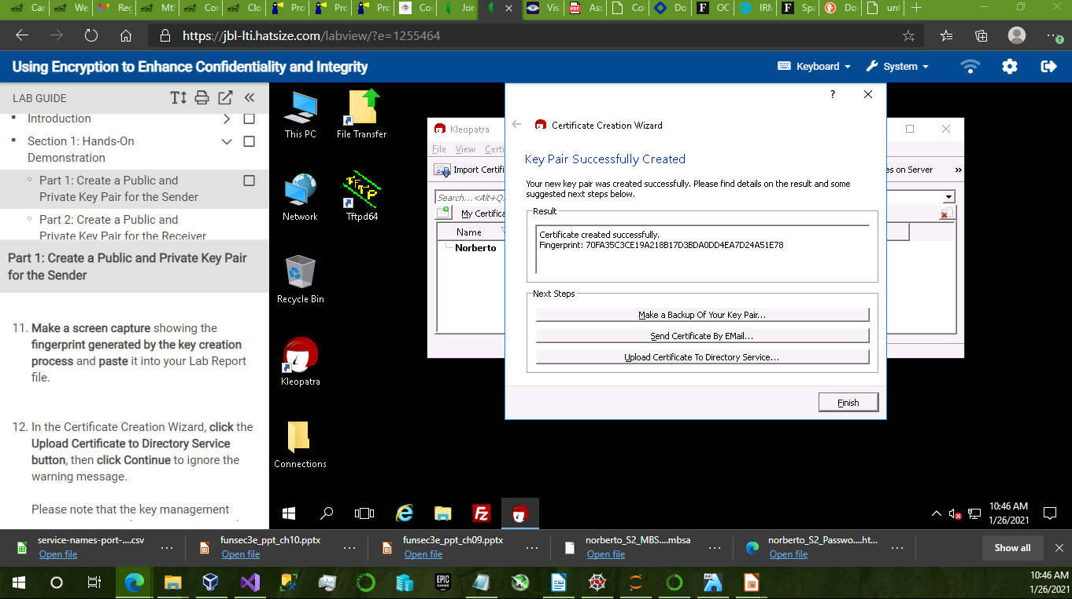

2. your name and email address in the certificate server certificate lookup dialog box

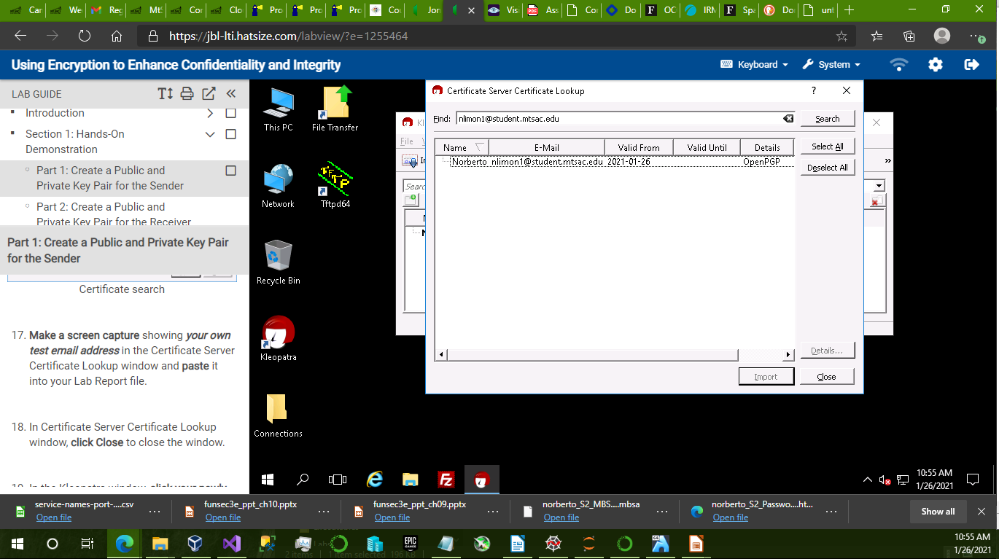

3. the Kleopatra decryption results window and the secret-message.txt file in Notepad

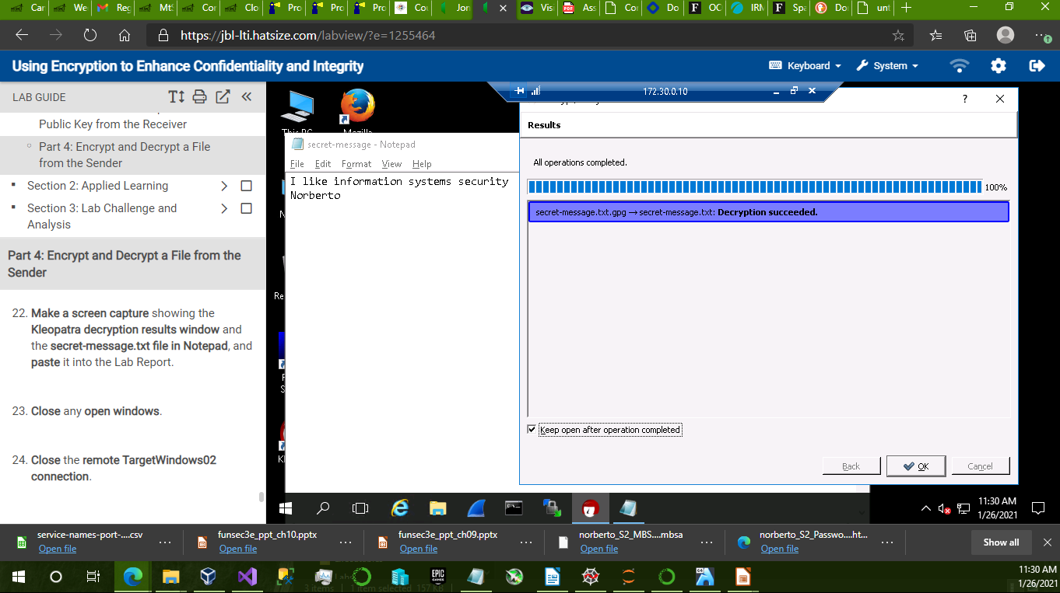

SECTION 2:

1. the fingerprint generated by the key creation process:

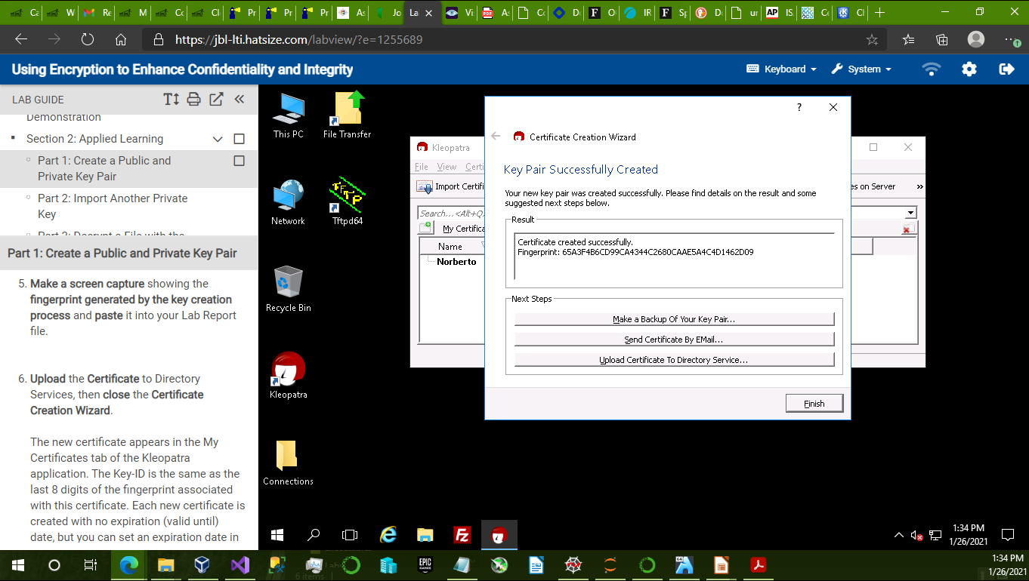

2. name and email address in the Certificate Server Certificate Lookup dialog box:

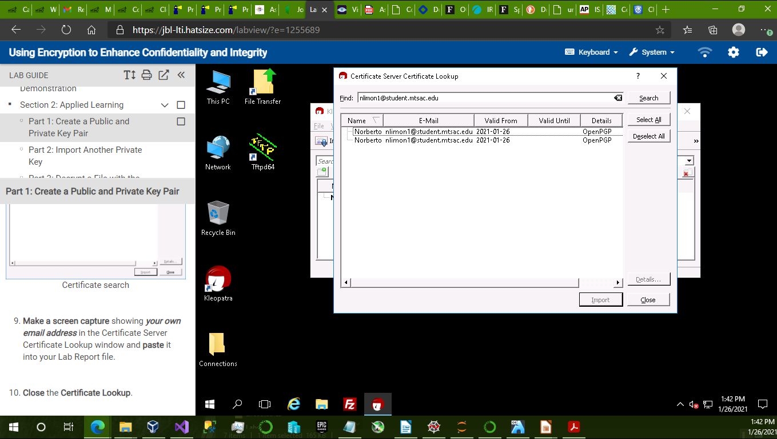

3. the Certificate Details dialog box for the imported certificates:

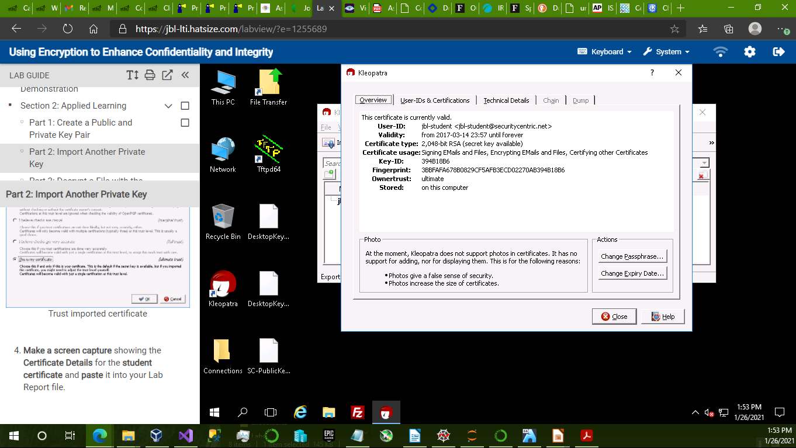

4. the successfully decrypted file:

